The Co-op Foundation #iwill Fund
Year 1 mid-year key learnings summary

Introduction

Co-op Foundation and the #iwill Fund
#iwill is a national campaign to promote social action among young people, set up by the Department for Digital, Culture, Media and Sport (DCMS) and the National Lottery Community Fund. The Co-op Foundation is one of several organisations that have committed to matching a portion of the #iwill Fund to distribute among youth social action projects. The Co-op Foundation’s matched Fund aims to support 76 youth social action projects across the UK between 2019 and 2022: 48 projects in Round 1 and 28 projects in Round 2 of funding. The projects are grouped into three thematic strands:
- School Transition, aimed at supporting young peoples’ wellbeing in the transition from primary school to secondary school
- Community Spaces, aimed at helping young people to improve the design and use of community spaces
- Bereavement Support, aimed at providing young people safe spaces and support to share their experience of bereavement

Co-op #iwill Fund evaluation
The Co-op Foundation commissioned IFF Research, an independent research and evaluation agency, to evaluate their matched #iwill Fund. As the Co-op’s evaluation partner, IFF are helping to capture evidence to understand the impacts projects are having on young people and the wider community, to identify what is working well and to summarise key learnings for projects to consider implementing to bring about intended impacts. At the evaluation start, IFF worked with the Co-op and stakeholders representing the three project strands to set out the impacts the Co-op hopes its Fund will achieve. These impacts, along with how those impacts are expected to come about, were developed into a theory of change for each strand. See the appendix for the theories of change.

Reading this summary
This Key Learnings summary shares findings from the first six months (March – August 2021) of funded project delivery in Year 1 (2020/21). It summarises what we know about the progress that projects have made towards the intended outcomes of the Co-op’s #iwill Fund. We also discuss key successes, challenges and learnings from project delivery experiences. Evidence captured in this summary is based on 21 grant manager interviews, six case studies involving project delivery staff and participating young people, and information captured in the Co-op Foundation’s monitoring form between May and August 2021 from 24 out of 48 Round 1 projects.

Progress towards intended outcomes
The Co-op Foundation intends for young people engaging with projects funded by its #iwill Fund to achieve seven outcome themes, and for the wider communities their projects are based in to achieve three outcome themes, summarised and defined in the table below.
Outcome theme | Core outcomes we hope to see achieved by projects. | Expected timeframe
Young people...
Participation | - Engage young people who do not have access to the services they need  - Engage young people whose voices are not heard  - Engage young people who live in an area with high levels of deprivation | 6 months  6 months  6 months
Lived experience | - Engage young people who have lived experience of the issues they are seeking to address | 6 months
Wellbeing | - build resilience  - are better equipped to cope with challenging situations | 2 years  2 years
Confidence | - have the confidence in themselves to set meaningful personal goals  - have the confidence in themselves to support others | 2 years  2 years
Connectedness | - feel part of a wider community  - feel they have good-quality individual relationships based on mutual trust and empathy | 6 months  2 years
Skills | - develop communication, teamwork and planning skills  - gain peer support skills (such as empathy, listening and leadership) | 6 months  6 months
Influence | - feel they have influenced support, services or spaces in their community or school | 2 years
Wider community…
Community influence | - Support, services or spaces are better informed and accessed by young people | 2 years
Community connectedness | - Community’s perceptions of young people more positive | 2 years
Community participation | - Have plans to deliver more youth social action projects | 2 years
Half (24/48) of the Year 1 funded projects submitted monitoring form information in time for this summary. Of these, three had not engaged any young people, and were unable to report on young people outcomes due to project start delays from the pandemic. Projects were asked by the Co-op Foundation to provide evidence towards a minimum of four out of seven young people outcomes. From these, projects could choose which outcomes to report on and the method for collecting evidence of the outcomes. This was in recognition that there may be some projects who do not seek to achieve some outcomes and because of Co-op’s commitment to reduce burden on projects engaging in the evaluation. Where numbers of projects and young people are given, this should be understood as evidence provided towards this outcome, rather than explicitly achieving it. Due to the differing size of projects by strand in terms of young people engaged, and the fact that this summary includes half of Year 1 projects so findings should not be treated as a complete and comprehensive representation of the outcomes of the Fund. The infographic overleaf summarises how projects have progressed against the above outcomes so far. We discuss each outcome in more detail in the following section.
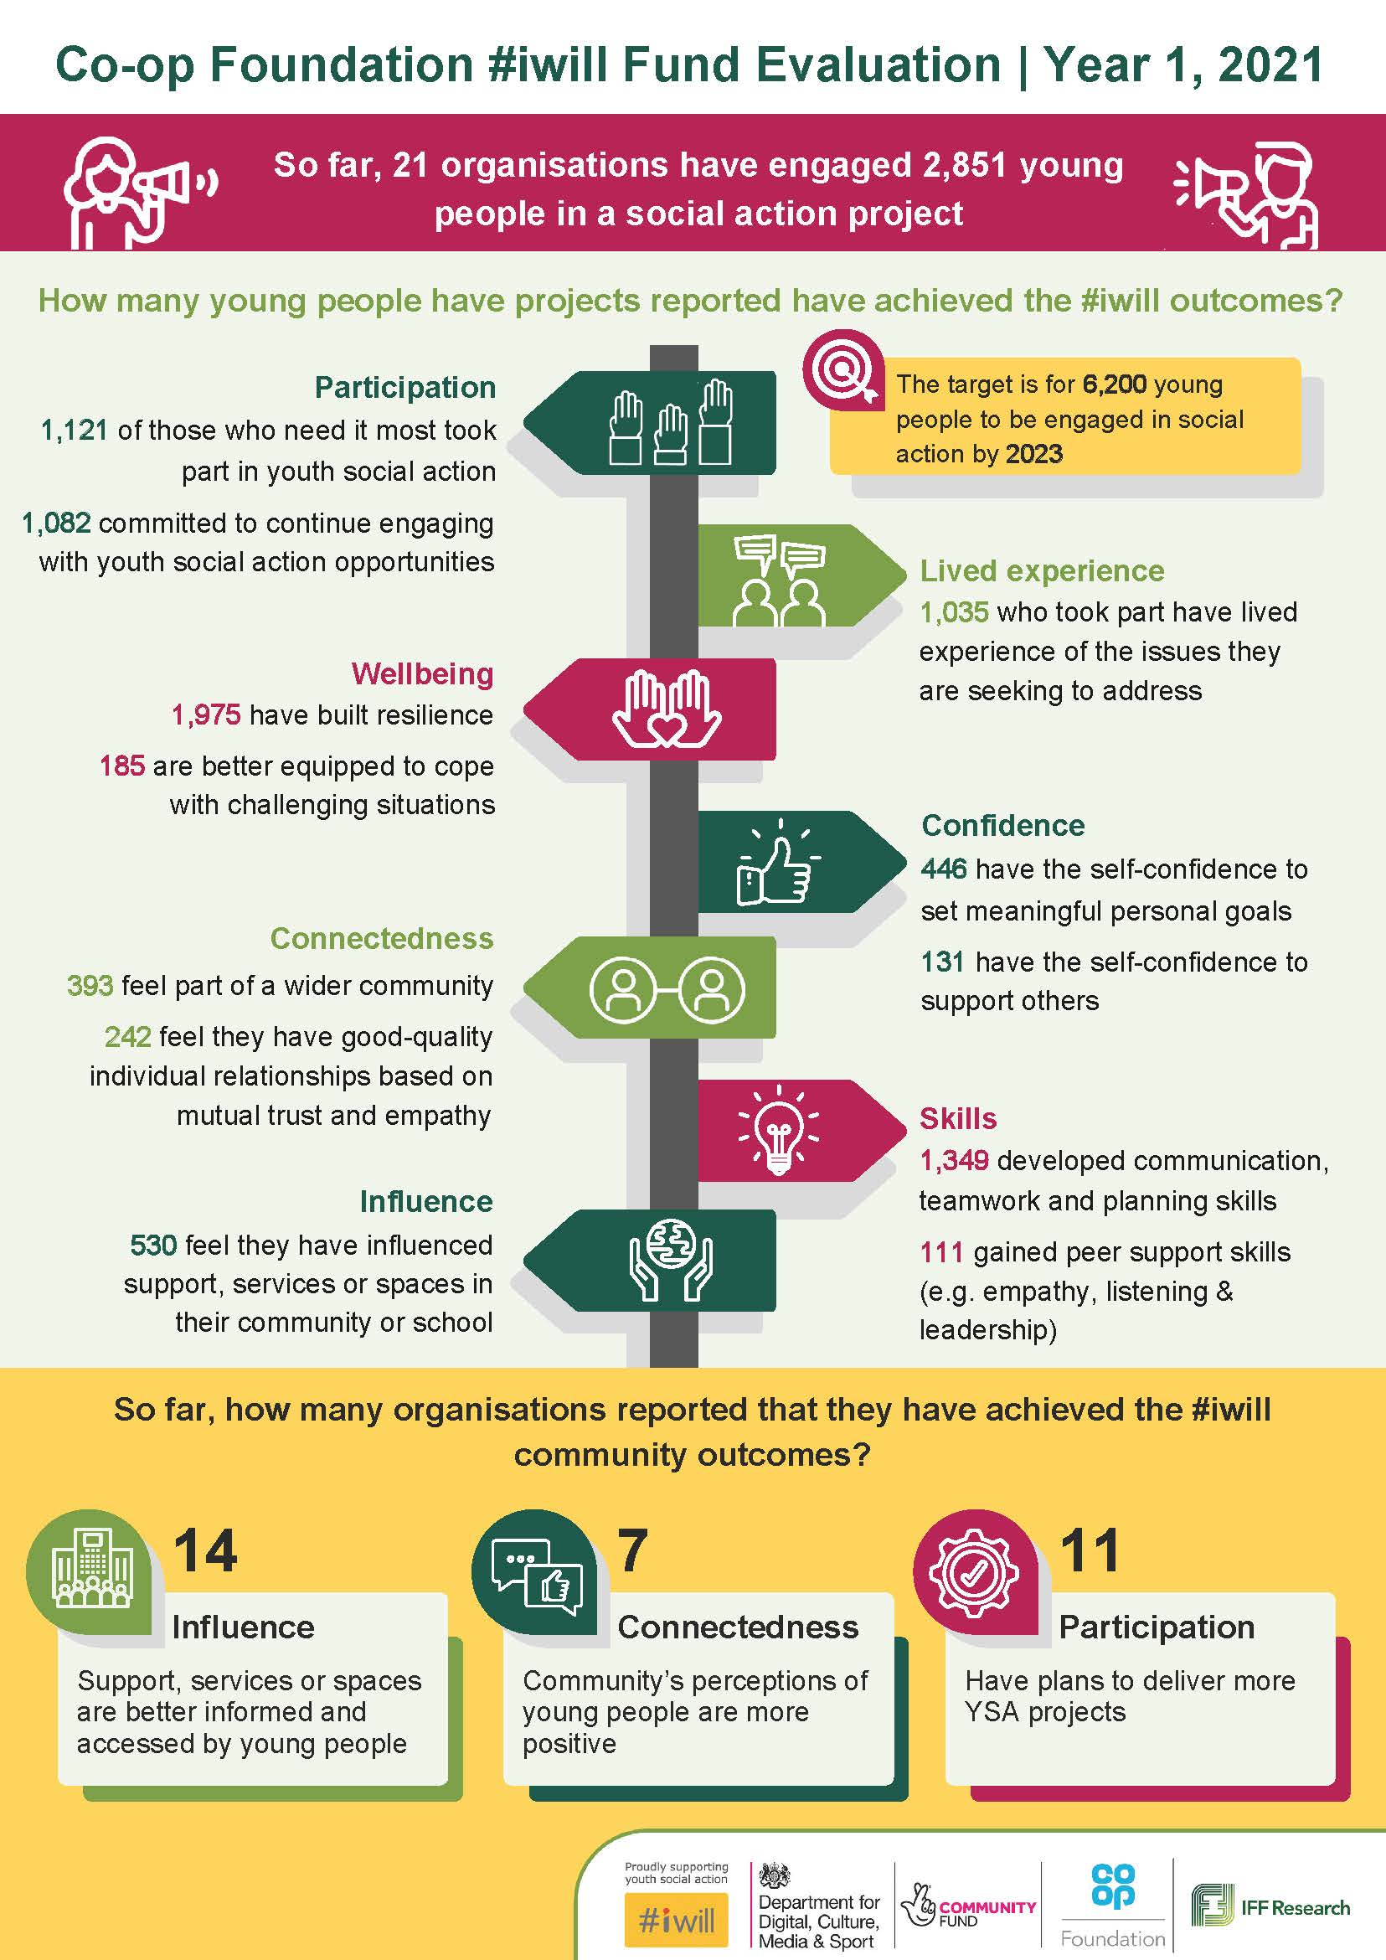

How are projects progressing in achieving outcomes for young people?

Participation: The Co-op Foundation intended for the Fund to engage young people ‘who needed it most’. This included young people who do not have access to the services they need; those whose voices are not heard; and those who live in an area with high levels of deprivation. Participation of young people who needed it most was expected within six months of project start because recruitment of young people to the projects was expected to happen within six months of receiving funding.
Numbers achieved | Nearly half of projects have started engaging young people in projects:19 out of the 24 that submitted monitoring information, from 48 funded Year 1 projects.  Together, these projects have engaged 2,851 young people so far, compared with the overall target of 6,200 young people the Co-op Foundation hopes its Fund will engage by the end of Year 2.  Projects reported minimal dropout among the young people they recruited to their projects. Less than half of organisations had experienced any young people dropping out of their projects so far: 9 out of 21 projects, totalling 41 young people who had dropped out.

Bereavement projects tended to engage smaller numbers of participants, between 2 and 30, compared with the other strands. School Transitions projects have engaged between 15 and up to 500 young people. Community Spaces projects were engaging the largest number of young people in their projects, with between 83 to up to 1600. From qualitative discussions with grant managers, the smaller numbers targeted among Bereavement projects appears due to the sensitive nature of the project topic, making them more suitable for smaller, focussed groups of young people.
Organisations that had engaged any young people so far (19/21 projects, totalling 1,121 young people) reported engaging young people from across the three categories of young people ‘who needed it most’, rather than from any one category. Over half (12/21) of projects reached some young people from all three groups. Most projects reported engaging young people who did not have access to services they needed (16/21 projects, totalling 677 people), and a similar proportion (14/21 projects, totalling 872 young people) reported engaging young people whose voices were not heard.

Lived experience: Engaging young people who had lived experiences of the issues the projects were trying to address was the second priority outcome.

Numbers achieved | Projects reported 1,035 young people took part who had lived experiences, though only 6/21 submitted this outcome via the monitoring form.

Evidence from interviews suggests most projects sought to engage young people with lived experience in their recruitment approaches. For example, young people who had experienced bereavement were sought for the bereavement projects and all young people taking part in School Transition projects had transitioned to secondary school in the past academic year. Some School Transition projects went further to secure the intended audience; for example, recruiting young people in school that teaching staff reported experienced a vulnerability in some way, or those at risk of exclusion.
Community Spaces projects followed a more varied definition of lived experience that generally related to different groups of young people that were less able to access local spaces and services. For example, young people identified as having special educational needs and disabilities (SEND).
Young people with lived experience was not a requirement for taking part in one project; the project was open to all young people interested in addressing a challenge in their community.
Wellbeing: The Co-op’s #iwill Fund aimed for young people to build resilience, and become better equipped to cope with challenging situations through project participation. Both of these outcomes were expected within two years of the start of the Fund so they are not expected to be fully realised by projects yet.
Numbers achieved | Most projects felt that young people had already shown early signs of improved wellbeing, with 1,975 young people across 12 of the 21 projects making progress towards building resilience.

Interviews with project leads and staff provides a better understanding of how resilience is understood by projects. When speaking about improved resilience, examples mainly focused on mental health, feeling confident to talk about sensitive issues and group bonding through shared experiences, rather than specifically about resilience.
Less than a third of projects (6/21 totalling 185 young people) reported that young people had become better equipped to deal with challenging situations.
For example, young people were observed by project leads in a School Transitions project applying skills learned in boxing and debating to deal with conflict with teachers. Some Community Spaces projects reported making a podcast about emotional wellbeing or learning skills to deal with challenging situations like pitching ideas to a panel. Bereavement projects tended to focus on the general emotional wellbeing of young people, as demonstrated by their willingness to talk about sensitive issues.

Confidence: The Co-op Foundation also hoped that involvement in the #iwill projects would bring young people increased confidence: both confidence in themselves to set meaningful personal goals; and the confidence to support others, like their peers.
Numbers achieved | Around a third of projects (7/21 projects totalling 464 young people) reported young people had the confidence in themselves to set goals, or the confidence to support others (7/21 projects totalling 131 young people).

Interviews with grant managers suggest projects across all three strands interpreted improved confidence through the lens of social confidence within a group setting; this differs from the intended focus of these outcomes on goal setting and supporting others. There were many inspiring examples of young people improving their social confidence, and young people proud of their contribution to the success of youth social action projects. There were few explicit mentions of confidence in setting personal goals. This may be an indication that this particular outcome needs refining, or to flag to projects that this is an important element of the outcomes which may need renewed focus.
Evidence so far suggests few projects have an explicit peer support element. This may emerge, as project delivery gets more underway in the second half of Year 1. School Transition and some Community Spaces projects were the exception; older and younger students and people were grouped together to collaborate on activities, and the older group gained experience of delivering peer support to their younger counterparts. Across both strands, few projects reported that building in a peer-review element to group activities helped to promote confidence among young people in delivering peer support.
None of the Bereavement projects had begun peer support activities, although several noted that young people had begun to support one-another more in their discussion of sensitive topics.

Connectedness: The Co-op’s #iwill Fund also sought to improve young people’s connectedness, which included young people both feeling part of a wider community and having relationships based on trust and empathy.
Numbers achieved | Less than half of projects that submitted monitoring forms reported that young people felt part of a wider community (8/21 projects totalling 393 young people).

Community is defined differently for projects in each strand:
- Community Spaces projects seek to engage young people with local spaces or issues. Project activities typically included activities the wider community could experience or respond to, such as art installations. For participating young people, this was a tangible and visible connection of their work to their communities.
- School Transitions project focus on the school community. In these projects, feeling part of the wider community included young people contributing more to classes or participating more in wider extracurricular activities, which occasionally also extended beyond school.
- Bereavement projects focus on bereaved young people beyond the core group taking part in the social action project, and the spaces or stakeholders young people engage with. For example, schools, home, and support services, or both, depending on the focus of the project.
Few projects provided evidence that young people had made progress towards having high quality relationships, as expected at this early stage. Around a third (6/21 totalling 242 young people) reported that they had relationships based on trust and empathy. Where this was reported, projects cited the strong social cohesion that had developed among the groups taking part in project activities. For example, young people were “looking out for one another” and showing each other empathy, which was particularly reported among School Transition and Bereavement projects.

Skills: By engaging young people in diverse youth social action projects, the Co-op’s #iwill Fund sought to build young peoples’ skills in communication, teamwork and planning, and peer support skills including listening, empathy and leadership. Evidence of both skillsets was expected by six months into project delivery.
Numbers achieved | Most young people were reported to have developed communication, teamwork and planning skills, with 1,349 young people and 17/21 projects reported to have achieved this.

Project staff shared examples of young people who initially were quiet and withdrawn at the project start, but over a few sessions began to share their views more, whether this was verbally, through the chat function of online meetings, or by email after the session. Terms of reference agreed between young people at the start of the project, and reinforced across the project, that included principles of respect and openness appears to be a useful mechanism so support communication.
Projects that involved group-based work to collaborate on developing materials, like website content, a community newspaper and social media posts, and whose delivery ethos involved minimal steer and input from project staff, provided the setting for young people to take personal responsibility for materials, and work together to coordinate how to achieve their goal. Young people interviewed from among Community Spaces and Bereavement projects felt project staff who gave the structure to work within, and reassurance they were available if needed, but otherwise kept quiet during brainstorming sessions was encouraging for the young people to try different planning approaches.
The second skills outcome, young people gaining peer support skills, had not been as clearly evidenced so far, with monitoring data suggesting 111 young people achieved this among 4/21 projects. It is worth noting that, due to project start delays, none of the Bereavement projects had started their peer-support elements so we may see progress against this outcome in the Year 1 summary.
For projects who had begun peer support delivery, evidence of listening, empathy and leadership was cited when the project involved training young people on what peer support is, why it is valuable and delivering activities that enabled young people to practice the skills they would need to deliver their youth social action project to their school or other schools. For example, young people each leading a part of the youth social project activity and working in small groups and feeding back to the larger group on behalf of their peers. Young people interviewed shared experiences of how ownership became easier with time, and as their confidence grew to follow through on tasks.
While most Bereavement projects had yet to start social action activities, young people interviewed felt better able to listen to others’ experiences and were becoming more open to discuss needs of bereaved young people and ideas for better supporting them, based on their own experiences.
Additional skills, beyond the focus of the #iwill Fund, were reported from participation in group activities. These skills included digital skills, from the experience of collaborating online to organise youth social action; creative and media skills, from producing youth social action content like videos, podcasts and social media posts; and professional and organisation skills from working to deadlines as a team to produce project deliverables.

Influence: An outcome expected to emerge by the end of project delivery (two years) was for young people to feel that they had influenced support, services, or spaces in their community.

Numbers achieved | Less than half of projects (9/21 totalling 530 young people) reported progress towards this outcome on the monitoring form.

However, from interviews there was evidence that projects in the Community Spaces and School Transition strands had made progress towards this outcome. Community Spaces projects tended to get young people involved in local services or spaces in some way, and therefore reported that young people had progressed in this by nature of the activities they were doing. For example, installing artwork in a local space; engaging with local services such as transportation via digital media; reaching out to venues and businesses in the local area to support projects. A project produced and distributed a newspaper around LGBTQ young people’s experiences in lockdown, and received positive feedback from local communities, including raising awareness of issues with gendered toilets at a local school. School Transition projects gave examples of young people feeling more able to speak up about issues they faced in school and feeling able to communicate their ideas more effectively.

How are projects progressing with achieving community outcomes?
While it is still early in project delivery, there is already emerging evidence of community outcomes. Over half of projects (14/24) reported evidence that support, services or spaces were better informed and accessed by young people. Early evidence of support, services or spaces being better informed and accessed by young people included projects signposting participating young people to available community services, like summer camps and gyms, and discussing issues that impact their communities, like a School Transitions project that debated the Sustainable Development Goals as part of their project activities.
Around a third of projects (7/24) reported evidence that the community’s perceptions of young people were more positive. Early evidence of more positive community member perceptions of young people included community member emails praising a newspaper the young people wrote around LGBTQ young people’s experiences in lockdown newspaper they then distributed to community businesses, and a project that facilitated young people to discuss the project’s focus with local cabinet members.
Just under half of projects (11/24) reported that they had plans to deliver more youth social action projects which represented 1,082 young people.

Project delivery experiences
This section discusses what projects have learned from their experiences so far, what challenges they have experienced and what approaches they have taken that have been particularly successful. Findings are from open text responses in monitoring forms from 24 projects, and qualitative interviews and case studies.

Setting up the project
Project set-up typically involved getting the resources and relationships in place to deliver the project, including developing training materials, recruiting and training staff, identifying spaces to run their activities and engaging partner organisations like schools, businesses and community organisations.

Successes
The following approaches were used successfully to set-up projects and indicate lessons learned for future projects.

- Leveraging existing relationships with other organisations by using these contacts as sources of support helped get projects off the ground quickly. This was particularly evident among School Transitions projects where organisations who already had strong links with one or more schools could swiftly build on that foundation to reach and engage high numbers of young people with their programme. For example, a School Transition project had 50 schools signed up to the project, many of whom they had pre-existing relationships with.
- Drawing from a pool of existing staff to resource the project also helped get projects off the ground quickly and ensured smooth delivery later down the line, by being able to bring in additional resource in crunch points. For example, when social distancing restrictions meant projects needed to quickly adapt their design to be delivered online, or when some young people taking part needed more one-to-one support from project staff initially to be able to engage with the project because of anxiety with group work or mental health concerns made worse by the pandemic. This was more likely for larger delivery organisations, who could draw upon additional staff as needed.
- Providing project staff and volunteers with safeguarding training delivered by subject experts. This was seen as particularly important among Bereavement projects. For example, a Bereavement project partnered with a grief charity who provided specific training, advice and expertise to the project lead about how she could talk to young people about bereavement, including a framework to help her understand how people respond to grief differently. Another project trained staff on various issues they may encounter in their project, like how to hav safe conversations about suicide.
- Maximising participation of young people in the project through established models of youth participation, and young people steering groups to inform the project focus at set-up. A Community Spaces project used the LUNDY model to ensure participation of young people from the outset. This academic model provides a way of understanding a child’s right to participation by considering four key elements in project delivery: space, voice, audience and influence. A Community Spaces project engaged groups of young people in the initial design of the project before they began recruiting participants to take part, to help them identify the types of spaces they would want to reclaim and types of activities they would like to run.

Challenges
The Covid-19 pandemic presented a significant challenge to project set-up and delivery. Projects often relied on partner organisations to set-up or deliver activities or provide facilities. The pandemic restrictions caused significant disruption to these arrangements:
- Delays in set-up because of limited to no partnership capacity to engage with the project, when needing to prioritise other work. Projects had to act quickly once restrictions had eased to re-engage with their partners but often found themselves competing with their partners’ other priorities and life generally being ‘busier.’ For example, schools prioritised exams and assessments over project engagement.
- Delays were often compounded by changes to set-up plans. This included where projects needed to find new partners because of the intended collaborators being unable to take part anymore. Issues accessing spaces for face-to-face activities because of social mixing and bubble restrictions, or community spaces and schools being closed, further delayed delivery. Some projects decided to reframe their project focus to be Covid-response related.
Projects were flexible and creative in responding to Covid restrictions. For example, moving delivery of activities online, moving activities to outdoor venues or securing large spaces like school halls that allowed for social distancing. A Community Spaces project put up art exhibitions outside a venue instead of inside, and a Schools Transition project ran virtual ‘taster sessions’ for Year 6s when the project was not able to deliver their project face-to-face as planned. A project also mentioned developing specific risk assessments in line with COVID-19 restrictions, to help the project go ahead and to ensure all involved felt safe to do so.

Recruiting target young people
A key aim of Co-op’s #iwill Fund is that the youth social action projects they fund engage young people who are most in need. This includes having lived experience of the issue, being under-served, or from a community that does not have its voice heard. Evidence discussed in the outcomes section above suggests projects have been successful in achieving this within their target audiences.

Successes
The following approaches were used successfully to recruit young people and indicate lessons learned for future projects.
- Using multiple channels to engage target young people, including advertising through social and local media, and through referrals from youth-focused organisations and school. Advertisements to community and project organisations’ Facebook, Twitter and Instagram accounts were employed effectively to recruit young people directly to projects.
- Established community organisations or leaders with strong links to the target youth were effective gatekeepers, as were schools based in areas of deprivation and teachers who could identify those who would benefit most.
- Recruitment of young people, and project delivery, was helped by the involvement of delivery staff with lived experience of the topic or previous experience of the target audience or project setting.
- Young person engagement was maximised where projects had tailored solutions in response to their assessment of individual needs during recruitment. For example, a Community Spaces project contacted young people individually beforehand either face-to-face or online to reduce their anxiety around participation in the project.
- Online delivery methods allowed geographically dispersed young people to participate and meant that more young people with shared experience could benefit. A Bereavement project observed that some of their participants came from rural areas where they did not know any other young people who had been bereaved. The lead felt that the young people benefitted greatly from the opportunity to connect with others who had been through the same experience they had. Another project described a young person joining sessions from overseas while they were travelling.

Challenges
Because of the pandemic, projects could not recruit face-to-face, as many preferred to do. However, project leads felt that recruiting young people exclusively through virtual methods had been challenging: some young people faced barriers to online access while others doing school remotely experienced ‘screen fatigue’. As a result, projects generally felt that take-up by young people was lower than it would have been otherwise.

Delivering activities
Projects were often in the early stages of delivery, had not yet begun engaging young people in peer support or in developing a solution to the issue they intended to address. Learnings around delivery therefore focus on engaging young people in the projects and encouraging positive relationships with other participants and project staff.

Successes
The following approaches were used successfully to deliver activities and indicate lessons learned for future projects.
- Allowing young people to take the lead was effective in maintaining their engagement and motivation. For example, in a Community Spaces project, young people had designed and led some of the green space activities themselves with little mentoring support from the project staff. The project lead reported high levels of enthusiasm from the young people for this approach.
- Using different activities or settings unrelated to the key project aim helped to encourage communication and build trust with young people who found it difficult to engage. Some projects had used activities like arts and crafts to put young people at ease and encourage them to be more open about personal experiences. This meant that they did not have to make eye contact with others while they were speaking. Others had run sessions in different environments, for example, outside of the school setting, which also encouraged young people to speak more freely.
- Creating an inclusive environment for young people. Projects had sought to do this by posting inclusive subject matter on social media pages; adjusting scheduling and group sizes to suit young people who had difficulties in large groups; or by using a welcoming and personalised one-to-one onboarding process. A Bereavement project ran specific workshops around different cultural interpretations of bereavement, which young people said helped them relate to and understand young people from different backgrounds.
- Some online delivery methods, such as webchat, enabled projects to engage young people with different learning styles or preferences, particularly those who may have been more nervous about taking part face-to-face. Projects addressing sensitive subjects felt that online platforms which allow participants to switch off their video or to write their thoughts in the chat or on a virtual whiteboard offered young people some anonymity that helped build their confidence and engagement. For example, a Community Spaces group delivering to LBGTQ children, and Bereavement projects noted this. A Community Spaces project referenced the fact that their website and chat function was always ‘live’, which meant that young people engaging with the project could easily access support whenever they needed it, whatever time of day. A Community Space project had switched training of young people to deliver green space projects to online which had worked well and will be continued. They adapted their existing face-to-face training programme and used the initial cohorts of young people to feedback on the materials and made improvements to them for subsequent cohorts. The online training programme also led to more regular contact than the previous face-to-face approach as they decided to run sessions weekly.
- Giving young people notice of session topics and reminding them of the projects agreed terms of reference, ahead of sessions, helped some young people better prepare to engage with sessions.
- Providing wellbeing support to staff who experienced wellbeing concerns from delivering project activities, particularly where the topic was sensitive, or where young people had complex needs. For example, a Community Spaces project paid for therapy sessions and wellbeing workshops for all staff. Another project set up their online chat service so that an experienced staff member supervised each session who had sight of the chats and could lend support by phone whenever needed. The supervisor ran feedback phone calls with the volunteers who were speaking to young people to give them support.

Challenges
Projects had typically been delivering their activities predominantly online, due to the pandemic restricting face-to-face interactions. Project leads found that delivering activities online presented technological issues for some participants and sometimes limited rapport. This was particularly the case for certain young people, for whom face-to-face activities were felt to be better suited to their learning styles. For example, a project working with Special Educational Needs and Disabilities (SEND) young people planned to move to face-to-face delivery when they could, because online interactions limited how well young people could recognise and understand the verbal and non-verbal cues of their peers.
A less common activity delivery challenge was around the pace of delivering activities. Some project leads talked about regularly revising their intended delivery plan and timescales once delivery started and they had a better understanding of the needs of the participating young people. Some young people needed more sessions and one-to-one support to engage how the project staff hoped, and this required adapting their delivery approach so it remained youth led.

Conclusions, lessons learned and next steps
This summary discussed the delivery journey of projects in their first six months of receiving #iwill funding and provides early evidence on the impact of the Co-op Foundation’s #iwill funded projects on young people and the wider communities projects are based. Projects were established in the context of the COVID-19 pandemic, with social distancing restrictions greatly influencing their ability to deliver their intended projects to their original timescales. The Round 1 projects included in this summary have set-up and recruited young people, with some also underway with delivering their social action projects.
Of the outcomes intended to be achieved by six months, participation and lived experience have been met, and most projects report having helped young people to develop communication, teamwork and planning skills. There is less evidence of some outcomes the Co-op had anticipated all projects would achieve six months into delivery that projects should reflect on whether and how they can bring these about and evidence them. These are building resilience (and not restricting this outcome focus to improved mental health); feeling part of a wider community; and gaining peer support skills. The latter two may emerge at the end of Year 1, once all projects are well underway with youth social action delivery.
It is too early in project delivery to comment on outcomes intended to be achieved in two-years, though there is early evidence that some projects are on track to achieve these. Projects should reflect on how they will bring out those young people and community outcomes and ensure they have the mechanisms in place to evidence this.

Projects have faced considerable challenges in setting up and delivering their project in a time of unprecedented change and uncertainty. There are key lessons for project delivery current and future projects may wish to consider going forward. The Co-op Foundation may also wish to reflect on these when considering Year 2 funding decisions. These are:
Set-up | - Leverage existing relationships and networks where possible; and minimise burden on these organisations by considering timing and relevant individual who are best placed to help. For partnership working with schools, busy periods such as the summer exam months need to be avoided. Additionally, non-teaching staff within schools may have more capacity to help with planning and set-up.  - Involve young people in project design to ensure project delivery and materials are appropriate and young people feel a stronger sense of project ownership.  - Provide upfront safeguarding training and support to staff around more sensitive issues; ideally facilitated by specialist external organisations or professionals.
Recruitment | - Use many different channels to identify and recruit target young people. This could include posting relevant content on relevant youth channels on Instagram and Tik Tok, digital spaces where young people spend time, that are less likely to contribute to their ‘screen fatigue’; taking referrals from teachers in schools and leads in community organisations, to benefit from organisational knowledge as to who is most in need. This helps to ensure that as many young people are reached as possible (even during pandemic restrictions).  - Consider recruiting through gatekeepers to lend legitimacy to a new project, especially when trying to recruit hard-to-reach groups; this could be an established and well-known youth or community organisation, and young people, ‘snowballing’ from recruited young people to their peers.  - Recruit project staff with backgrounds and experience most relevant to the target young people and/or approach and topic of the project.  - Blended delivery approaches of online and face-to-face, where feasible, may help widen participation to young people more geographically dispersed, and will help ‘future proof’ delivery in the face of further social distancing restrictions. For the former, this could be young people living outside the target community, who live in the target community but attend college or university elsewhere or who travel for some of the project.
Delivering activities | - Adapt delivery to different learning styles, offering options for young people to take part in ways most comfortable to them. This could be via breakout rooms, or one-to-one sessions, providing support through websites and chat, and possible options for face-to-face interaction.  - Share session plans to young people in advance of sessions to help those who need time to consider the topic and prepare their thoughts, so they can feel better able to contribute to sessions.  - Identify potentially sensitive or emotionally intense periods of project activity and provide proactive support around wellbeing to staff at these times.

Next steps
The evaluation team will discuss with the Co-op Foundation the implications of these findings on the evaluation design with the view to refine the monitoring form guidance so it supports all projects to evidence their effect on young people and the wider community. This will be circulated to all projects.
The below are some upcoming key dates for the evaluation:
  - Follow-up discussions with project lead, about ongoing project delivery and emerging outcomes: Scheduling to begin in December 2021, with the aim for discussions to take place across January and February 2022.
  - Analysis of monitoring forms for all of Year 1: March 2022
  - Next key learnings summary shared: April 2022
If projects have any questions about the evaluation or have additional evidence to share to support our understanding of how #iwill funded projects are benefiting young people and their communities, please get in touch, on IWillResearch@iffresearch.com.

Theory of Change – Bereavement
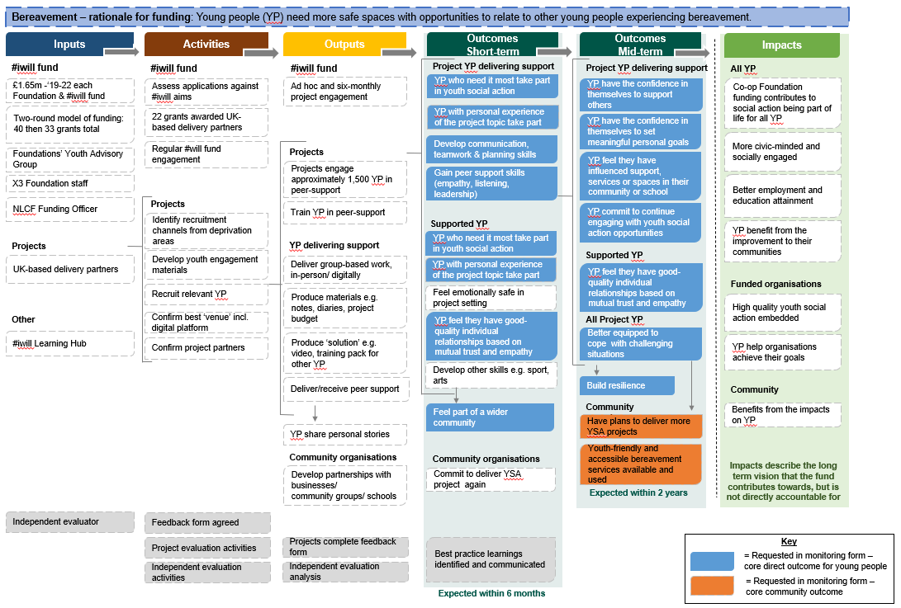

Theory of Change – School Transitions
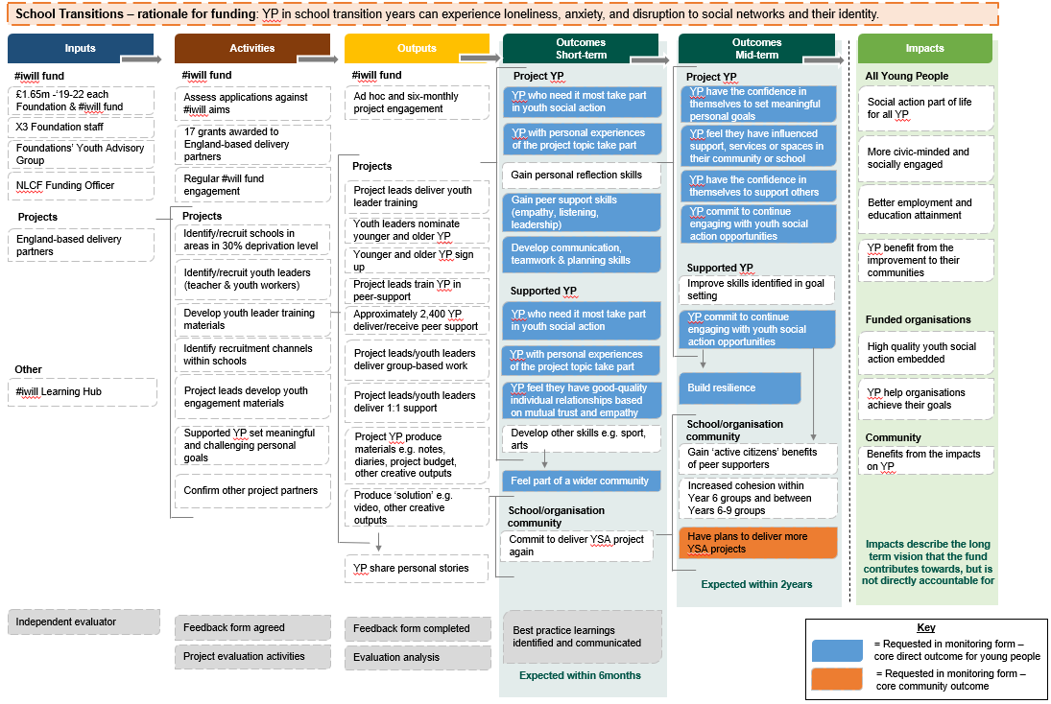

Theory of Change – Community Spaces
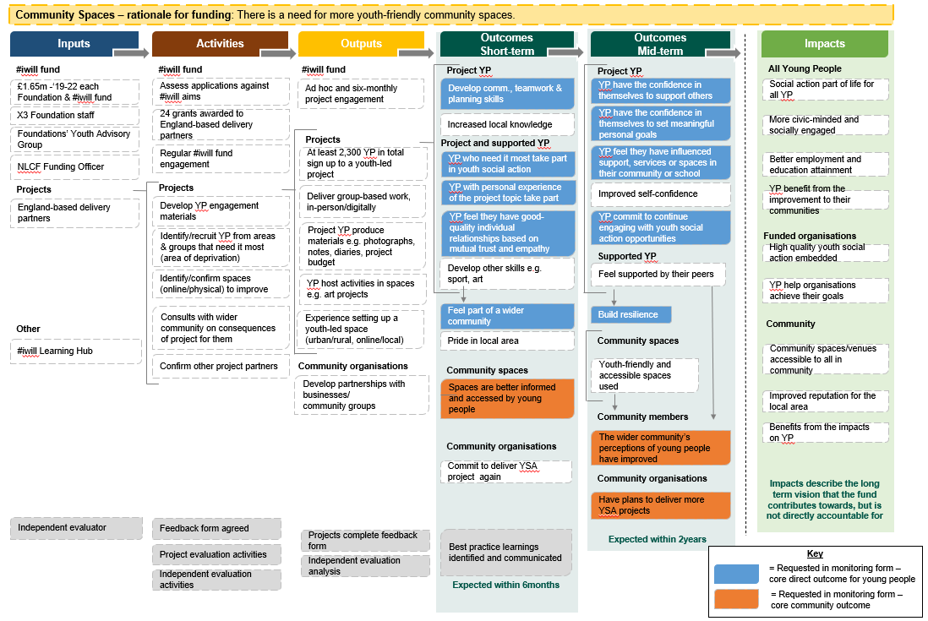

Larger font is available upon request.
Decision-making: children and young people's participation - gov.scot (www.gov.scot)

